Tel Megiddo, Israel
Dr. David Jeremiah – The World of the End (pg.49-50).
“The hieroglyphics in at the Karnak temple in Egypt provides a description of the first recorded war in the history of the world. April 16, 1457 BC, between Pharaoh Thutmose II and a large coalition of Canaanite tribes led by the King of Kadesh. Both armies boasted about 10,000 men. The Egyptians routed the Canaanite forces who retreated to their walled city, known as Megiddo. The Egyptians besieged the city and took it seven months later.
What’s interesting to me is the location of this war…The battle between Egypt and the Canaanites-the FIRST recorded battle in world history…occurred in the Valley of Armageddon. This conflict is commonly called “the Battle of Megiddo.”
From the top of Tel Megiddo, one views the vast Valley of Jezreel, also known as the Valley of Armageddon. Today it’s the breadbasket of Israel, a perfect agricultural plain that yields huge amounts of barley, wheat, oranges, beans, watermelon, chickpeas, and sunflowers. But throughout history, that area has been the scene of countless conflicts-as many as two hundred battles.
It’s from THAT EXACT SPOT that the Antichrist will set up his forward operating base in the final war of history (Rev. 16:16). The very name Armageddon comes from the Hebrew term Har Megiddo, or the “Mountain of Megiddo.” Interestingly, Megiddo was not originally a mountain. It’s an archaeological “tel,” or manmade hill, that gained its height from the repeated destruction and rebuilding of the city.
Our planet has a land surface of more than fifty-seven million square miles, yet the first and last recorded battles in history were )and will be) fought in the same place. These two wars serve as bookends, in a way, to the history of warfare. Between them is volume after volume of the bloody battles that mar the human story.”
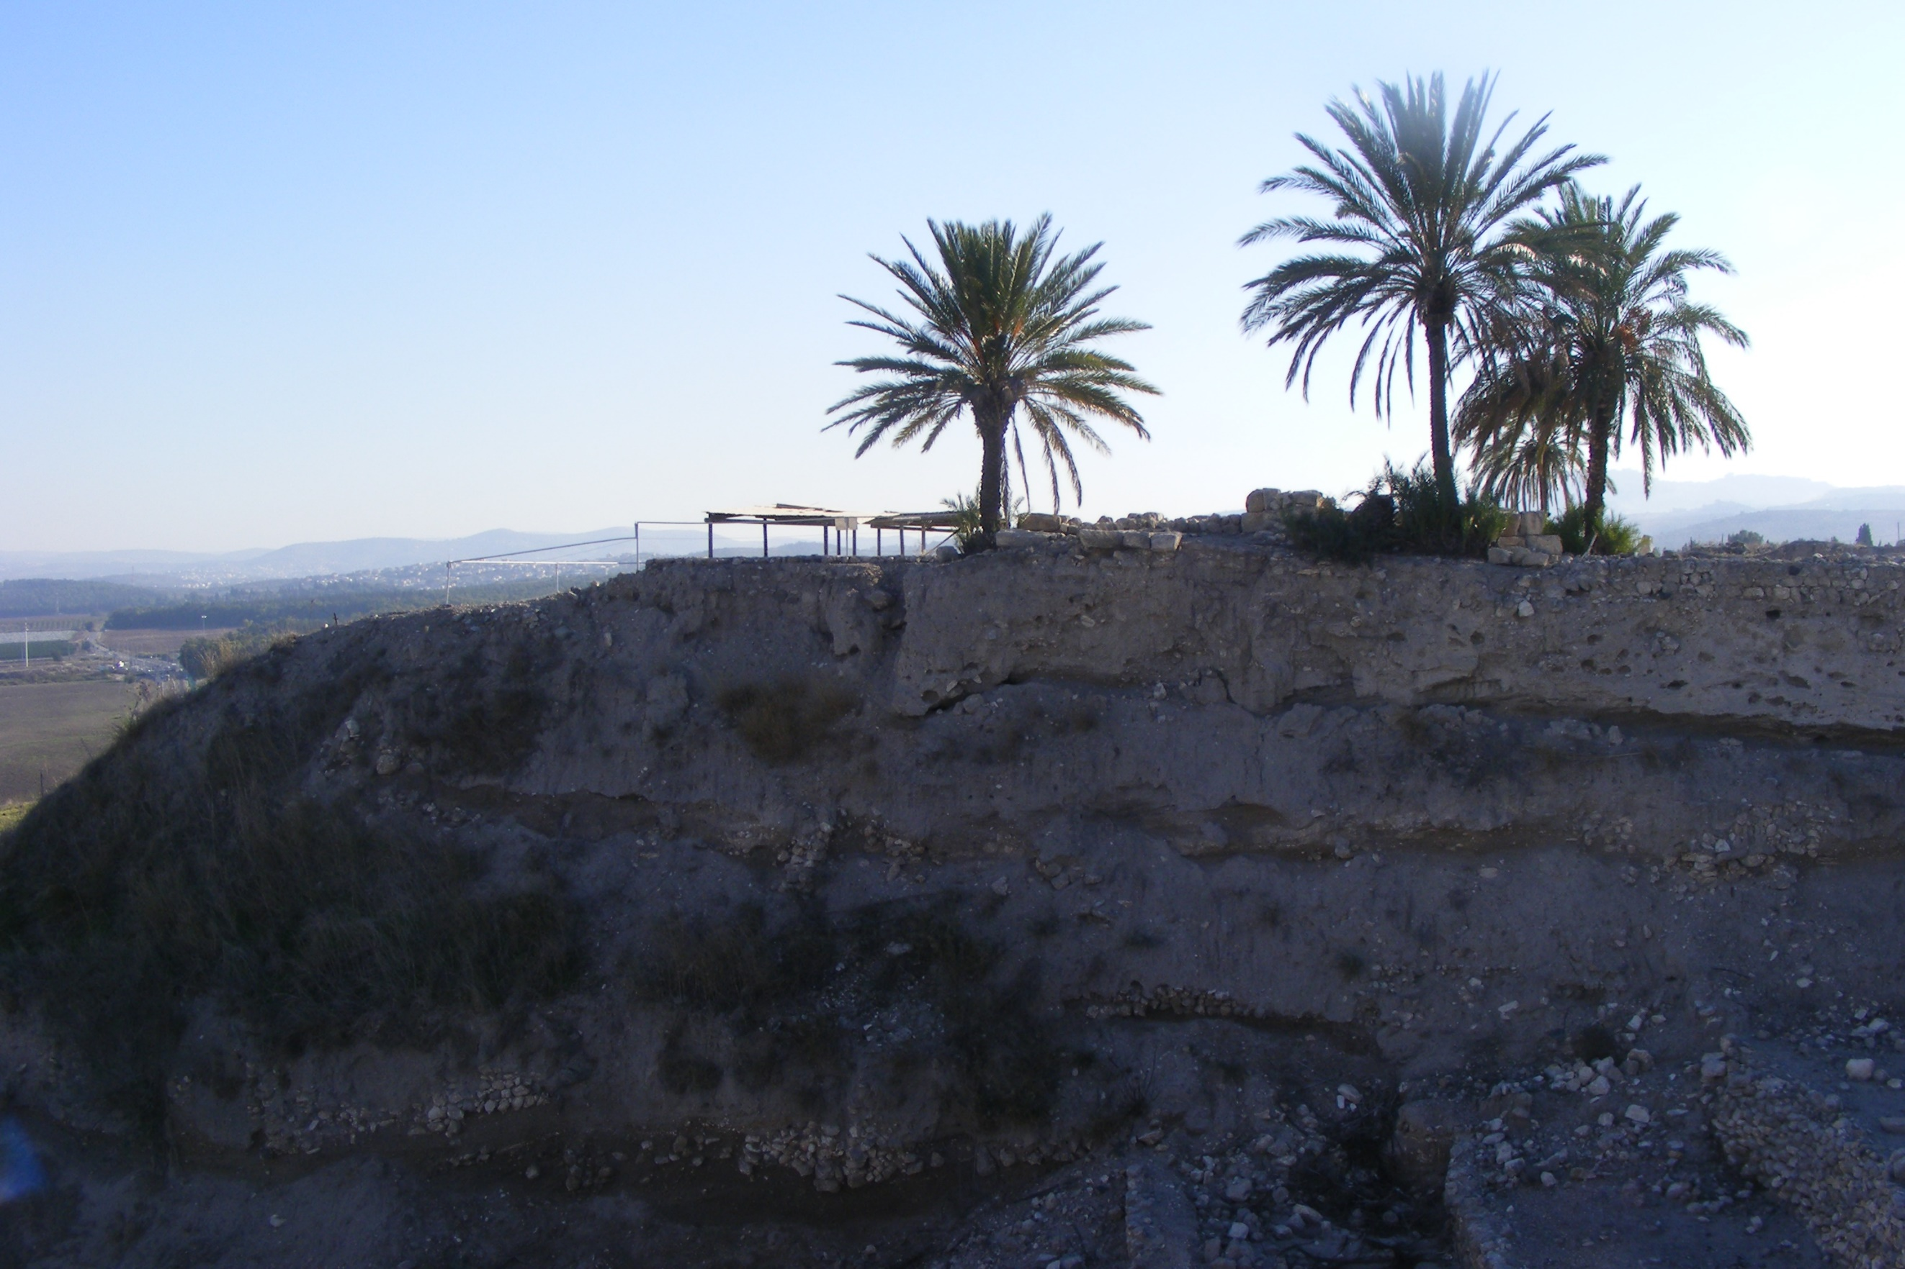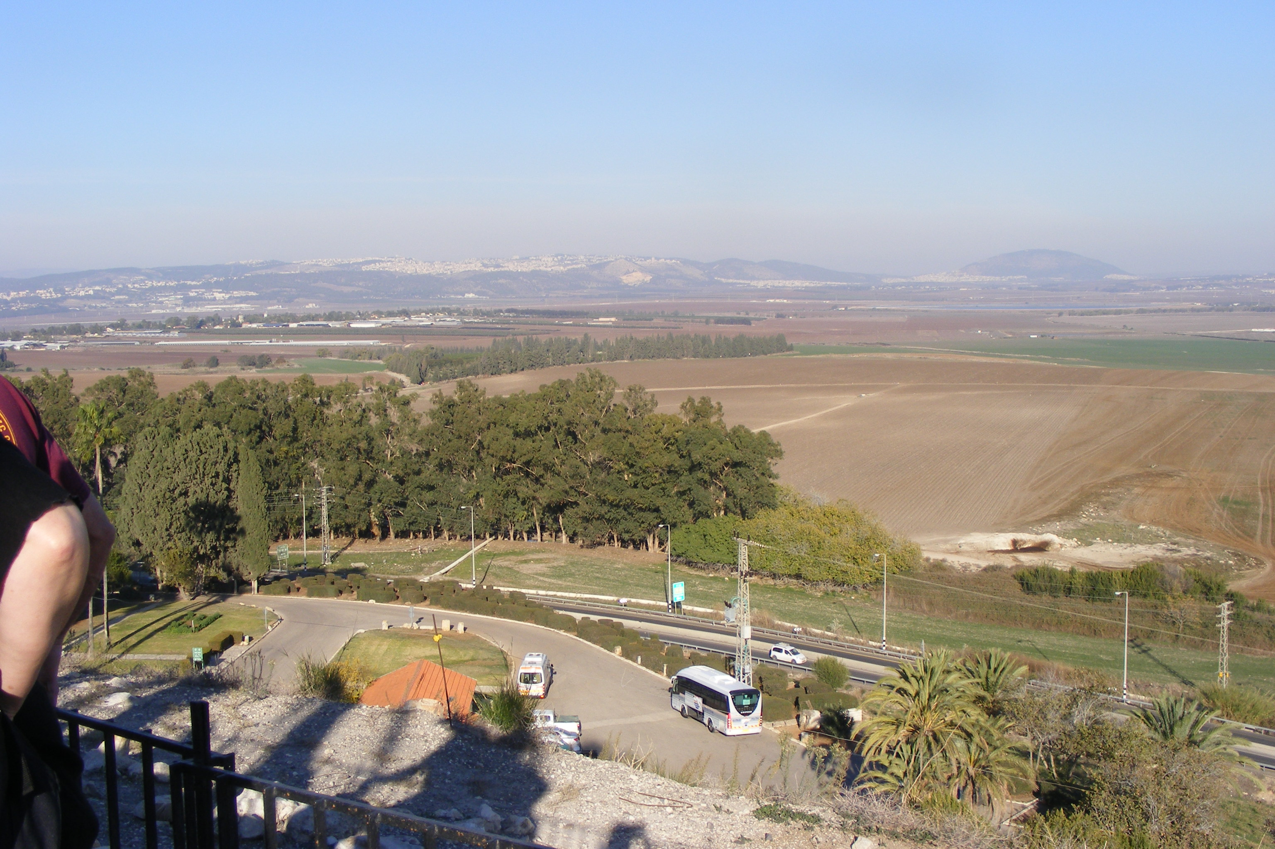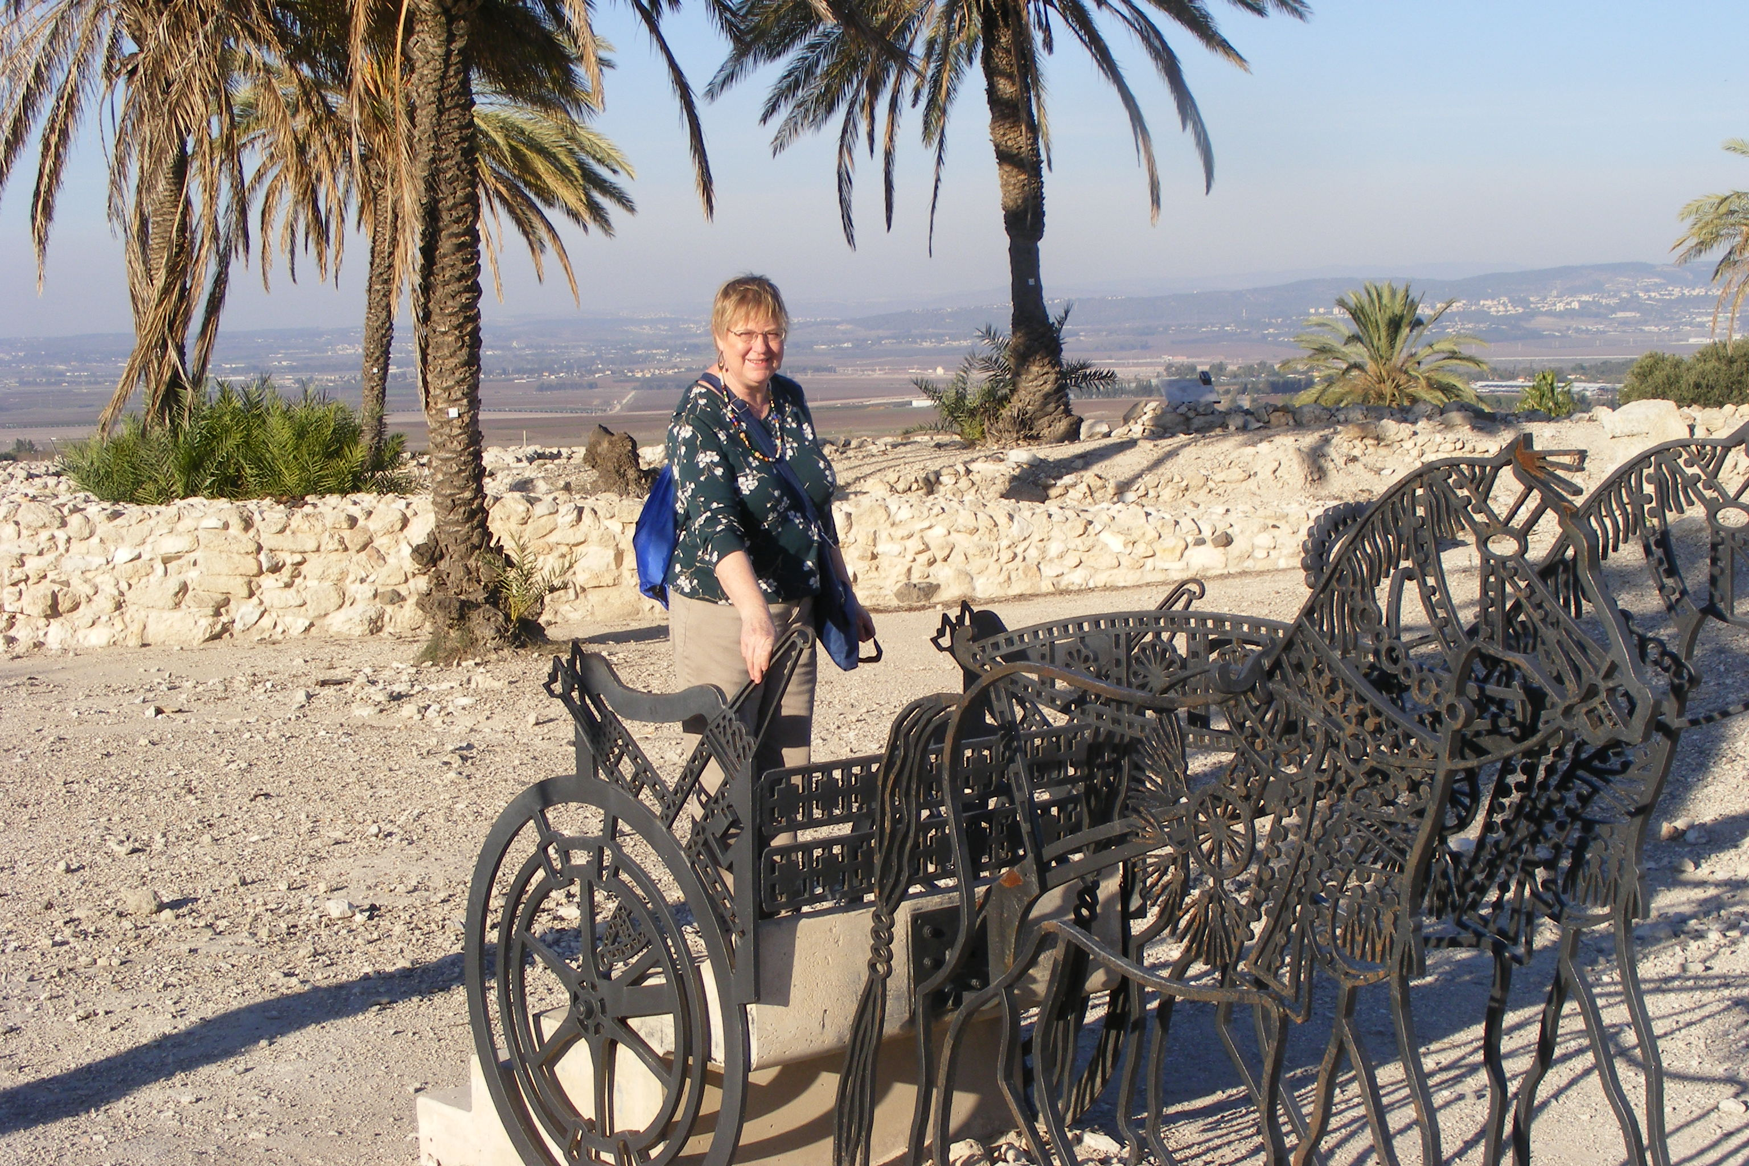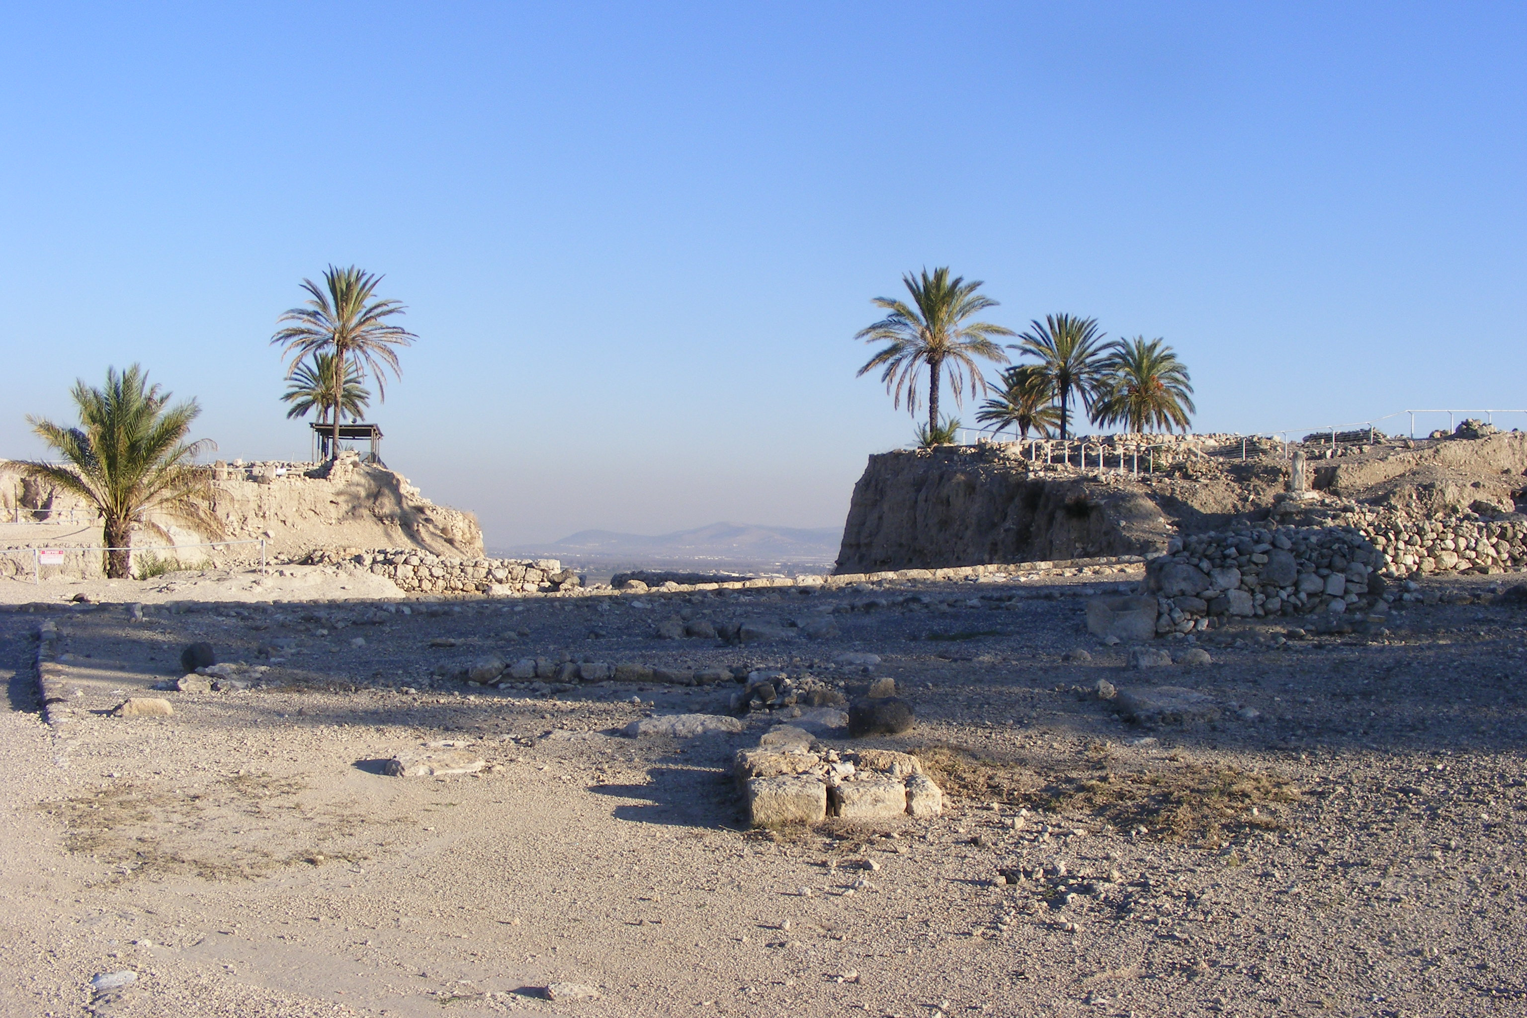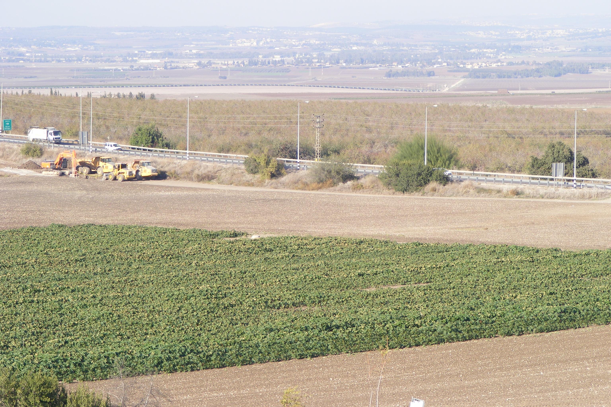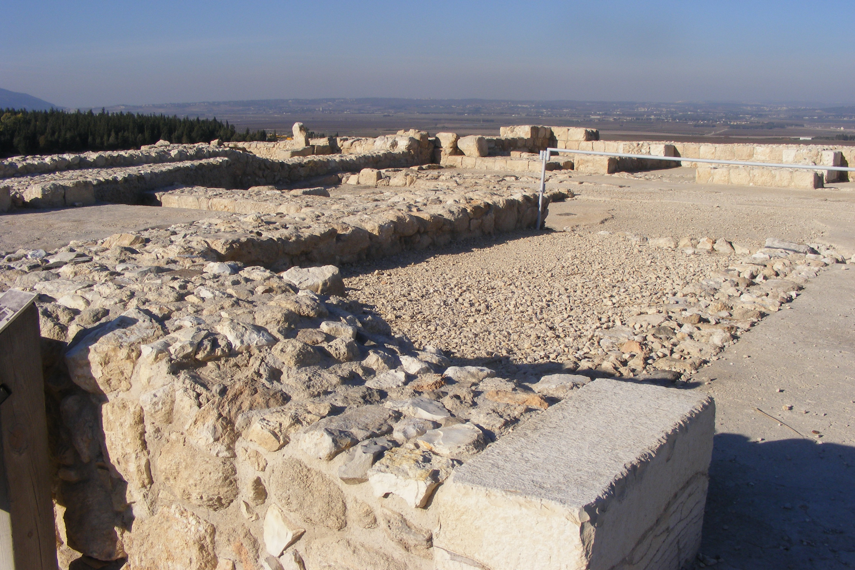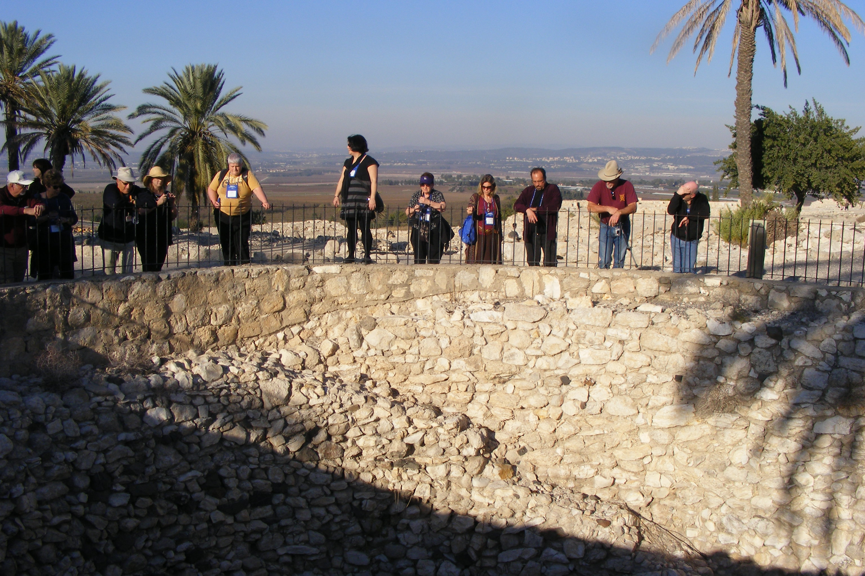
More information
GOOGLE SEARCHES
Tel Megiddo is the site of the ancient city of Megiddo, the remains of which form a tell, situated in northern Israel near Kibbutz Megiddo, about 30 km south-east of Haifa. Megiddo is known for its historical, geographical, and theological importance, especially under its Greek name Armageddon. Wikipedia
What is Megiddo according to the Bible?
In Christian apocalyptic literature, Mount Megiddo, the hill overlooking the valley where the current kibbutz is located, is identified as the site of the final battle between the forces of good and evil at the end of time, known as Armageddon and mentioned in the New Testament in Revelation 16:16.
Why is Tel Megiddo important?
History. Megiddo was important in the ancient world. It guarded the western branch of a narrow pass on the most important trade route of the ancient Fertile Crescent, linking Egypt with Mesopotamia and Asia Minor and known today as Via Maris. Because of its strategic location, Megiddo was the site of several battles.
Northern Israel
Megiddo, modern Tel Megiddo, important town of ancient Palestine, overlooking the Plain of Esdraelon (Valley of Jezreel). It lies about 18 miles (29 km) southeast of Haifa in northern Israel.
Location
The importance of Megiddo was its geographical location along the southwestern edge of the Jezreel Valley just beyond the Mount Carmel ridge and the Mediterranean. From this location, Megiddo controlled the Via Maris, the main trade route between Egypt and Mesopotamia.
Looming over a strategic spot on Israel's northern coastal plain, the ancient city of Megiddo was often a battleground, befitting its biblical name Armageddon. But in two Bronze Age tombs, archaeologists are finding signs that, nearly 3500 years ago, Megiddo was also a surprisingly cosmopolitan place.
MEGIDDO
Megiddo, an impressive site in the Lower Galilee region of northern Israel was once an ancient city was critical that dominated the Aruna Pass (Wadi Ara or Megiddo Pass) the entrance to one of the few passes through the Carmel Mountains. This gave those who occupied Megiddo incredible power over the Via Maris, the main route between Egypt and Mesopotamia and what the Egyptians called the Way of the Sea. Today, Megiddo is a UNESCO World Heritage Site, and an impressive site to visit and explore. Megiddo features on many Israel Holy Land tours due to its rich Biblical importance.
Tthe city has seen more battles than any other location in the world. Fortress cities sit upon the 10 acre summit of Megiddo Hill or Tel Megiddo, rising 21.33 meters above the valley. From this vantage point, battle after battle throughout history took place.
For Christians the word Megiddo is synonymous with the end of the world as mentioned in the Book of Revelation. Megiddo, or Armageddon, will be the site of the Final Battle. This will be the final battle of many fought here.
Excavation has uncovered about 26 layers of settlements dating back to the Chalcolithic period. The first four layers have been identified. The hill top was a Canaanite city, an Egyptian fortress, a Chariot City during Biblical times, and a prominent Assyrian and Persian city. King Solomon ruled the city in its prime in the 10th century BC. Visitors can see the remains of Solomon’s Gate and his stables. The Ivory Palace is another major structure in Megiddo. It was here they located Canaanite treasure, including valuable ivory and jewelry.
In the Middle Bronze Age the Canaanites fortified the hill top and a gate remains. From the 3rd millennium BC you can see an altar 10 meters in diameter with a staircase leading up towards it. An Iron Age water system is also evident. There is a 30 meter deep shaft and 70 meter long tunnel from the 9th Century BC when the city was ruled by Ahab. It is possible to walk through this tunnel. It would have supplied residents with water from the nearby spring.
Visiting Tel Megiddo
You can spend about an hour or two seeing the sites at Megiddo and the site is open year round. When visiting, you can go to the museum which uses models to recreate the original structures that stood here. They also show an informative film. This is one of the most impressive sites in the Lower Galilee
Prices 28.00 New Israeli Shekel - Open April to Sept. from 8-4, and Oct. to March from 8-5 Friday 8-3) ____________________
Megiddo was an important Biblical city. The site is situated on the gateway on the road linking North and South of Israel, about 30 Km south-east of Haifa. The archeologists uncovered 26 layers of ancient cities. (Bible Walks 500+ sites)
_______________________________________________________________________________________
Excellent information at https://biblewalks.com/megiddo (for great details, photos and diagrams). Northern Stables and Palace:
On the north side was a complex of 12 horse stables, dated to the 8/9th century BC (Israelite period). Remains of the north most stable, with stone pillars and troughs, are seen here. The remaining stables on the south side of the complex were removed to dig into the earlier Canaanite period.
The stable walls were built with mud-bricks over a foundation of large square cut stones.
Horses and chariots were important factor during those times, and Megiddo was an important “Chariot city”. The Bible expressed the might of king Solomon by the huge number of horses that his army had (1 Kings 4:26): “And Solomon had forty thousand stalls of horses for his chariots, and twelve thousand horsemen”.
Note that other scholars consider the stables to actually be storage rooms. However, there are many signs that support the theory of the stables, and may be one of the most important evidence of King Solomon’s structures in Megiddo.
Sanctified Area:
In the east side of Tel Megiddo is an area where a total of 17 temples were built in the course of 2,000 years of the city, starting from the early Canaanite/Bronze period (3300-2900BC) up to the Late Canaanite/Bronze period (1200 BC). New temples were not added after the Israelite conquest.
An aerial view, captured from the east side of the mound, shows the area of the temples on the lower side.
The next photo is a a view from the west side. This deep trench was cut by the archaeologists in order to explore the different layers of Tel Megiddo. There are a total of 26 distinct layers of the city – starting from the Neolithic period (8300-4500 BC) on the hill’s bedrock, up to the last layer of the Persian period (586-332BC). Each layer raised the height of the ground, thus increasing the height of the Tel from period to period.
Indeed, Megiddo was a fortified “Chariot city”, one of several chariot cities of the Judean Kingdom (see Bible references). King Solomon (reign 970-931 BC) had 1400 chariots and 12,000 horses, while Ahab used 2,000 chariots in his battle against the Assyrian King Shalmaneser III (853 BC). There were 5 stables in this complex, as well as 12 in the northern complex, with a total of 450 horses or more.
One of the stables were reconstructed, and seen in the photo below. The plan of the stable was based on 3 long sections, separated by rows of stone pillars and troughs between them. The middle section was a long central hall, with side aisles flanking both sides of the hall. The central hall was wide enough to allow a cart to deliver the grain and hay to the troughs and turn around to the other side.
Assyrian city
In 732 BC was an intrusion into the North of Israel by the Assyrian King Tiglath-Pileser III, who annexed the area: (2 Kings 15: 29): “In the days of Pekah king of Israel came Tiglathpileser king of Assyria, and took … Galilee…and carried them captive to Assyria”). Megiddo then became the capital of the region under Assyrian rule.
An aerial view of the Assyrian city is seen here in the aerial view, looking towards the west.
Youtube Video – Drone Footage
https://biblewalks.com/megiddo#Canaanite%20Gate
An aerial view of Tel Megiddo can be seen in the following YouTube video (captured in September 2019), where our drone circles the mound, starting and ending in front of the ancient city gates:
Megiddo is mentioned 18 times in the Old Testament.
Joshua 17:11-12 The Bible tells that the city was not conquered by the Israelites (Tribe of Manasseh) at the time of the conquest of Israel: 11 And Manasseh had in Issachar and in Asher Bethshean and her towns, and Ibleam and her towns, and the inhabitants of Dor and her towns, and the inhabitants of Endor and her towns, and the inhabitants of Taanach and her towns, and the inhabitants of Megiddo and her towns, even three countries. 12 Yet the children of Manasseh could not drive out the inhabitants of those cities; but the Canaanites would dwell in that land.”
(b) 1 Kings 9:15- Only later, during King David’s times, the city became part of the Jewish state. His son, King Solomon, constructed the great walls, including the famous gate which was later unearthed by the archaeological digs. “And this is the reason of the levy which king Solomon raised; for to build the house of the LORD, and his own house, and Millo, and the wall of Jerusalem, and Hazor, and Megiddo, and Gezer.”
(c) 1 Kings 4:26 “And Solomon had forty thousand stalls of horses for his chariots, and twelve thousand horsemen”.
(d) 2 Kings 15:29 The Assyrians captured the Galilee (732 BC), and made Megiddo the capital of the region.
” In the days of Pekah king of Israel came Tiglathpileser king of Assyria, and took Ijon, and Abelbethmaachah, and Janoah, and Kedesh, and Hazor, and Gilead, and Galilee, all the land of Naphtali, and carried them captive to Assyria”.
(e) Kings 2: 23:29
King Josiah tried to block the armies from Egypt to pass through Megiddo, but was defeated there (year 609BC) which was a terrible tragedy for the Jewish state.
“In his days Pharaohnechoh king of Egypt went up against the king of Assyria to the river Euphrates: and king Josiah went against him; and he slew him at Megiddo, when he had seen him.”
Identification:
There is no doubt on the fact that this Tel is indeed the true site of Megiddo, although the Arabic name of the hill did not preserve the name.
Etymology (behind the name):
Megiddo – referred in many texts in the old Testament. The source of the name is not clear. Perhaps it is based on the root G-D-D, or Gdud, meaning: battalion (a great army was stationed here), or a mound (the city was built on an impressive mound).
Megiddon – another form of the name
Armageddon – the nearby Mount Megiddo (Har-Megiddo) probably gave its name to Armageddon which is referred in the Old Testament
History of Megiddo:
40th C BC – Early Neolithic and Chalcolithic settlements
20th C BC – The massive city walls were built
18th C BC – A new gate is constructed in the north side.
15th C BC – The gate and walls were rebuilt.
15th C BC – The city rebelled against the Egyptians with other Canaanite cities, and was conquered by Thutmose III after a great battle and a 7 month siege (1468).
14th C BC – Mentioned in the Amarna letters, an Egyptian archive of clay tablets.
10/9th C BC – New gate and walls built by the Israelites (Solomon, Ahab or Jeroboam)
945 BC – Pharaoh Shishak conquers the city, as per 1 Kings 14: 25 (a fragment of tablet with his name was found here)
732 BC – The city was captured by the Assyrian King Tiglath-Pileser III. Megiddo became capital of the Assyrian province of the Galilee.
609 BC – The Egyptians replaced the Assyrians. Battle between the Egyptian Army and the Kingdom of Judah (King Josiah, who died in this battle)
3rd C BC – The city was abandoned; the Tel is in ruins since then
1918AD – Battles between the British and the Turks in WW1
1949AD – Kibbutz Megiddo was established on the south side of the Tel.
______________________________________________________________
New Visitor Center Opens in Megiddo (April 15, 2021)
"The site combines nature, archaeological finds and biblical history, and unfolds the story of the history and heritage of the Land of Israel over some 6,000 years. The state-of-the-art and technological visitors center, in which a great deal has been invested, makes the history of the place accessible to the general public in an interactive and fun way, with videos and models that 'resurrect' figures from history and even the geographical area of the area. We see the importance of returning Israeli travelers to a place where they can walk among the finds and learn about the history of the Bible."
The entire Tel Megiddo National Park covers 274 dunams and includes several points of interest, chief among them the ancient waterworks – a magnificent engineering system that was quarried in the 9th century BCE, without any technological means. The plant served as a secret water source, at a time when the city was under siege. You can also see the walls, the large stone gates and the remains of the stables that housed some 5,000 horses – and these illustrate the power of the city of Megiddo in ancient times. Only recently was the Israeli gate restored from the time of King Solomon. The northern viewpoint of the site provides a spectacular 360-degree panoramic view of the Jezreel Valley.
Tel Megiddo is one of the first archaeological sites excavated in Israel, and the one that carried out the largest number of archaeological excavations in Israel and around the world. In 2005, the site was recognized as a World Heritage Site by UNESCO.
The tell is decorated with palm trees – thanks to the excavation workers who came from Egypt to work with the American expedition that excavated the site in 1925. It is said that the Egyptians brought with them dates from the banks of the Nile as a side to the road, and the kernels were the ones that sprouted - and today the trees are an inseparable symbol of Tel Megiddo.
The nature here doesn't disappoint either. Above the mound you can see falcons that nest in the area, including the rare red falcon. The site also includes a "black centipede" – a centipede located in the Alps at Tel Megiddo, with researchers still trying to find an answer to the question of why he lives en masse here.
Those looking for activities for the whole family will find escape spaces in Tel Megiddo National Park with code kits that need to be cracked. At the end of the activity, the families who crack the riddle will receive the "Seal of Megiddo", which bears the name of Jeroboam, probably Jeroboam II, and is the earliest seal of an Israelite king discovered so far. The code kits can be purchased at the Visitors Center for 20 NIS.
The national park is open to visitors Sunday-Thursday and Saturday from 17:00 to 8:00, and on Fridays and holiday eves until 16:00. Entrance fee: 28 NIS per adult, 14 NIS per child (from age 5), free for Matmon subscribers. The visit must be arranged in advance through the Nature and Parks Authority website.
Water Tunnel
Megiddo's Water Tunnel (which guaranteed the town's water supply) is the site's major tourist attraction. Take the path leading from Megiddo's Stables to find it.
The water tunnel was formerly attributed to the 13th or 11th century (in the time of the Canaanites or Philistines), but excavations have now firmly dated it to the Israelite period in the time of Ahab (9th century BC).
The source of Megiddo's water is a spring in a cave outside the town. In the time of Solomon, a two-meter-wide shaft was cut through the walls to give access to the spring on the southwest slope of the site.
Ahab resolved to construct a conduit at Megiddo, which would run from inside the town to the spring, and in the event of a siege, would not be accessible to the enemy.
A shaft was driven down through earlier occupation levels and then through the rock to a depth of 60 meters, and from this, a horizontal tunnel was cut through the rock to the spring for a distance of 120 meters. (150 steps down into the tunnel.)
Temple Complex
Although it can be hard to imagine, the temple complex was once a mighty and monumental piece of architecture (see the reconstruction in Megiddo Museum).
The Eastern Temple consists of a vestibule, the main chamber, and the holy of holies.
The rear wall of the holy of holies backs on to the temple with the circular altar. Built against the inner wall is a square altar approached by steps on the side.
Adjoining this temple on the west are other cult buildings, presumed to be a Double Temple for a divine couple. On the valley side are remains of walls from an older temple dating from the Chalcolithic period (4th millennium BC).
History of Megiddo
Excavation of the tell of Megiddo began in 1903-05 with the work of the German Palestine Society, when Schumacher cut the deep, wide trench on the east side that bears his name.
Between 1925 and 1939, the site was systematically investigated by the Chicago Oriental Institute, and in 1960, Yigael Yadin began the excavations, which established the chronology of the site.
This work showed that after a period of occupation in the Neolithic era there was a Canaanite settlement here in the 4th millennium BC, which continued in existence until the Israelite occupation. From this period there is a Chalcolithic shrine and another one nearby with a large circular altar.
After a battle in 1479 BC, in which Pharaoh Tuthmosis III gained control of the pass during his advance to the Euphrates, the town was under Egyptian influence. In the Tell el-Amarna archives (14th century BC), letters were found from the Egyptian governor asking for military reinforcements against the Habiru (which may be referring to the Hebrews).
In the 13th century BC, Joshua, after his triumph over the king of Hazor, also defeated the king of Megiddo (Joshua 12,21), but the Israelites held the town only for a short time, for in the 12th century, the Philistines,thrusting inland from the coast, conquered Megiddo and the whole of the Jezreel plain as far as Beth-shean.
A new phase began around 1,000 BC when David defeated the Philistines.
In the 10th century, Solomon made Megiddo the chief town of the fifth administrative region of Israel, extending as far as Beth-shean, with Baana son of Ahilud as its governor (1 Kings 4,12).
To the east of the main gate, Yigael Yadin's excavations brought to light a Northern Palace dating from this period, probably the royal residence, and one of the casemate walls characteristic of Solomon's time, like those at Hazor and Gezer, as well as the formidable North Gate.
On the south side of the site were the palace of the governor, Baana, and an administrative building. "This was not a mere fortress but a metropolis with imposing buildings designed for ceremonial purposes" (Yadin).
The Solomonic city was destroyed in 923 BC by Pharaoh Sheshonq (the Shishak of the Old Testament) and had to be rebuilt by King Ahab in the 9th century.
On the site of the North and South Palaces, stables were built for 450 horses (long known, erroneously, as "Solomon's Stables"). Ahab, who no doubt attached particular importance to Megiddo because of its situation on the road to Phoenicia, his wife's home country, renovated the Solomonic gate, built a strong new wall round the town, and dug a large tunnel to ensure its water supply.
Thereafter, Megiddo enjoyed a period of prosperity, which ended in 733 BC with its conquest by the Assyrians in the reign of Tiglath-pileser III.
In 609 BC, King Josiah of Judah was killed at Megiddo in a battle with Pharaoh Necho.
After the Persian conquest in 538 BC, the town was abandoned, but in Roman times, a camp occupied by the sixth Legion was built two kilometers south of the tell. This gave its name to the Arab village of Lajun, now the kibbutz of Megiddo.
In more recent times, Napoleon (in 1799) and General Allenby (in 1917) won victories over Turkish armies at Megiddo, and again in 1948 the Israelis defeated Arab forces here.
https://www.planetware.com/afula/megiddo-isr-nr-md.htm
_________________________________________________________________________________
Other video’s
https://www.google.com/search?q=tel+megiddo+visitor+center&ei=QU7ZY9uQFKS1ptQP-bCM2A4&start=10&sa=N&ved=2ahUKEwibtdGSqfL8AhWkmokEHXkYA-sQ8tMDegQIBhAE&biw=716&bih=742&dpr=1.25#fpstate=ive&vld=cid:ea9510f5,vid:YPEtMa_Q7jQ

https://www.google.com/search?q=tel+megiddo+visitor+center&ei=QU7ZY9uQFKS1ptQP-bCM2A4&start=10&sa=N&ved=2ahUKEwibtdGSqfL8AhWkmokEHXkYA-sQ8tMDegQIBhAE&biw=716&bih=742&dpr=1.25#fpstate=ive&vld=cid:fc39ca14,vid:57XcRlDZRH8

